The Jain International School , Kanpur
Class – LKG
SUBJECT | SUMMER HOLIDAY HOMEWORK
English | Do the given worksheets.
Hindi | Do the given worksheets of Worksheet Hindi.  (Pages 16,17,18,19,20,21,22)
Mathematics | Do the given worksheets of Numeracy Classwork .  (Pages-4,5,6,7,8, 12,15,16,17,18,19)
EVS | Do the given worksheets.
Cursive Writing | Do the given worksheets of My Cursive Writing Book.  (Pages -1-10)
Art | Do the given worksheets.
Craft | 1-Make a handprint elephant by chart papers.  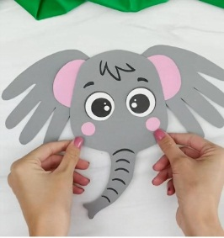  2- Make a snail by using handmade papers.  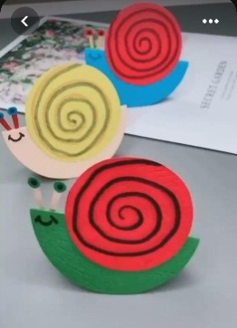  3.Make a bunny by using thermocol glass ,Straws and chart papers .  4- Make an umbrella by using ice cream sticks , thermocol plate and chart papers.  