The Jain International School, Kanpur
Class – Nursery
SUBJECT | SUMMER HOLIDAY HOMEWORK
Literacy Class work | Do the given page number  8,9,10,15,16,19
Numeracy Class work | Do the given page number  2,5,6,7,8,9
My cursive writing work book | Do the given page number  11,12,13,14
Fun reading | Learn Alphabets A-Z with sound and pictures
Hindi Rhymes | Learn Hindi Rhymes (Page number 1-6)
English Rhymes | Learn English Rhymes (Page Number 1,2,3,4,7,8,9)
Project Work | *Make an ICE-CREAM with the help of Chart and Cotton  *Make “BUTTERFLY” with colorful paper 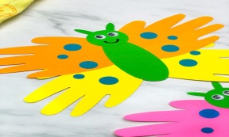  *Make “TURTLE” using paper plate 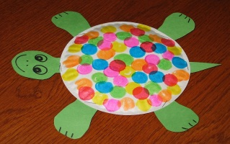  * Make “FAMILY TREE “with the help of chart paper and paste family picture  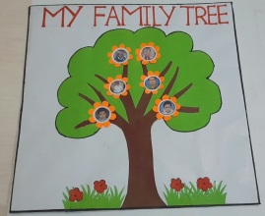
Father’s Day | - Make a beautiful card for your father for Father’s Day celebration and share the picture in the class groups

