The Jain International School , Kanpur
Class – UKG
SUBJECT | SUMMER HOLIDAY HOMEWORK
English | Do the given worksheets of worksheet Literacy book.  Page no. 1,10,13,14,17,19,21,23
Hindi | Do the given worksheets of worksheet Hindi book.  Page no. 1 and 2
Mathematics | Do the given worksheets of worksheet Numeracy book.  Page no. 1,2,8,11,13,14,16.
EVS | Do the given worksheets of worksheet General awarness book.  Page no. 24-28,31,33
Cursive | Do Pg. no. 32 to 39.
Art and craft | - Make a photo frame with ice cream sticks and paste your family picture. 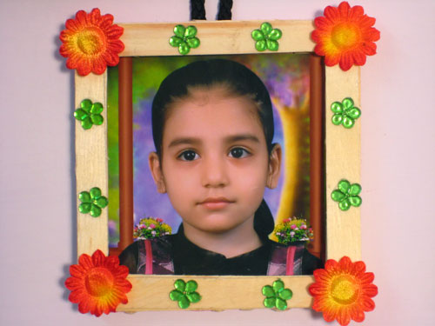  - Make a lady bug by using paper plate .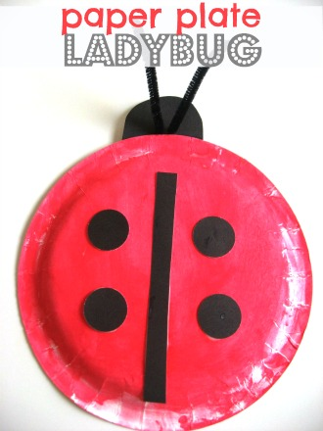  - Make a paper plate rainbow . 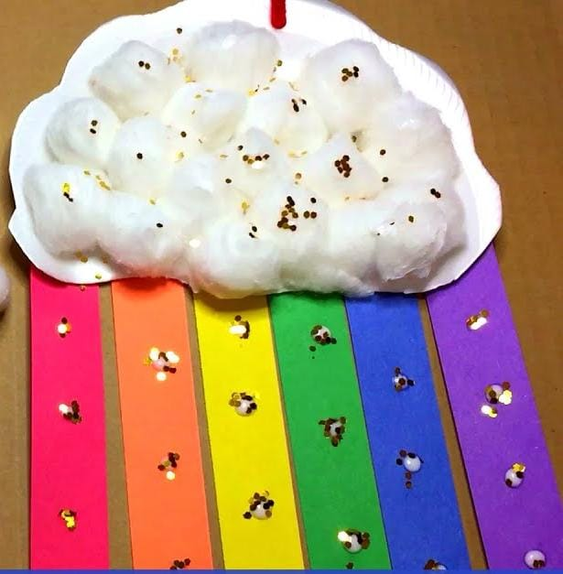  - Make a paper boat by paper folding.